OPERATIONAL MONITORING ENGINE

# WIDGET 1 – INFO CARD

## HT DISTRIBUTION PANEL

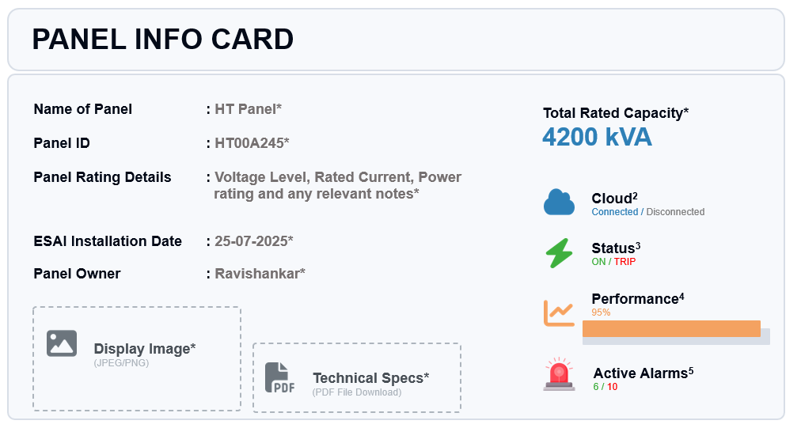

1. (*) GET this data from HT System Config Panel and Display in this widget. Applicable for all HT Distribution Panels
2. GET the RealTime Cloud connection status Device UID Column in DB
3. GET from
   1. If (AVG_VLL == 0) - Tripped
   2. If (AVG_VLL ~ HT Nominal Voltage) – ON
4. GET from
   1. RealTime value stream – HT Widget 15
5. GET from
   1. HT Alert Log Page – Total Active Alarms

## LT DISTRIBUTION PANEL

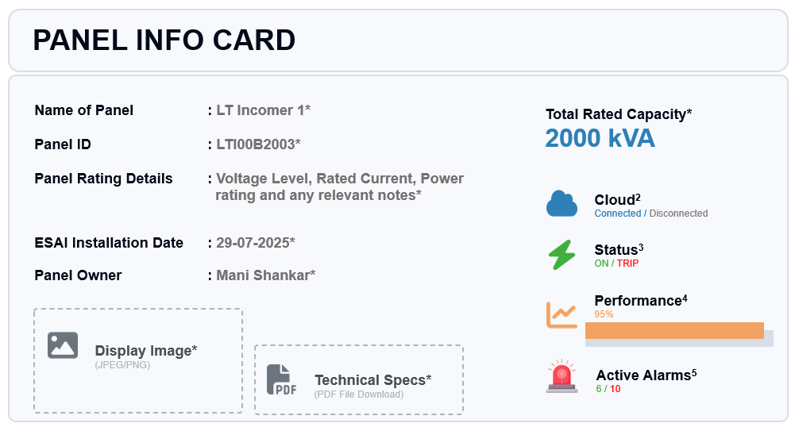

1. (*) GET this data from LT System Config Panel and Display in this widget. Applicable for all LT Distribution Panels (E.g., PCC-5, Feeder-6, MCC)
2. GET the RealTime Cloud connection status from Device UID Column in DB
3. GET from
   1. If (AVG_VLL == 0) - Tripped
   2. If (AVG_VLL ~LT Nominal Voltage Range) – ON
4. GET from
   1. RealTime value stream – LT Widget 15
5. GET from
   1. LT Alert Log Page – Total Active Alarms

## INDIVIDUAL MACHINE

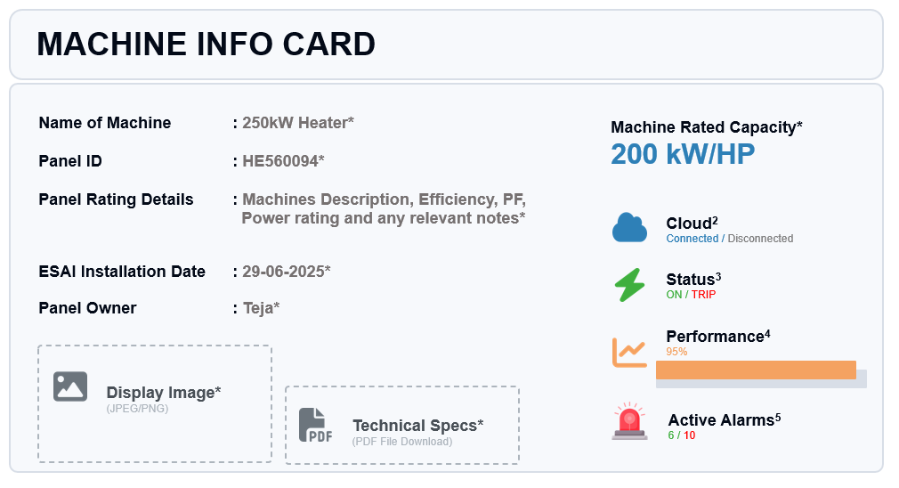

1. (*) GET this data from Machine - System Config Panel and Display in this widget. Applicable for all Individual Endpoint Machines (E.g., Heaters, Press, Chillers)
2. GET the RealTime Cloud connection status from Device UID Column in DB
3. GET from
   1. If (AVG_VLL == 0) – OFF/Tripped
   2. If (AVG_VLL ~ Nominal Voltage Range) – ON
4. GET from
   1. RealTime value stream – Machine Widget 15
5. GET from
   1. Machine Alert Log Page – Total Active Alarms

# WIDGET 2 – 3PH LINE - LINE VOLTAGE

## HT DISTRIBUTION PANEL

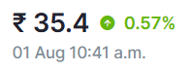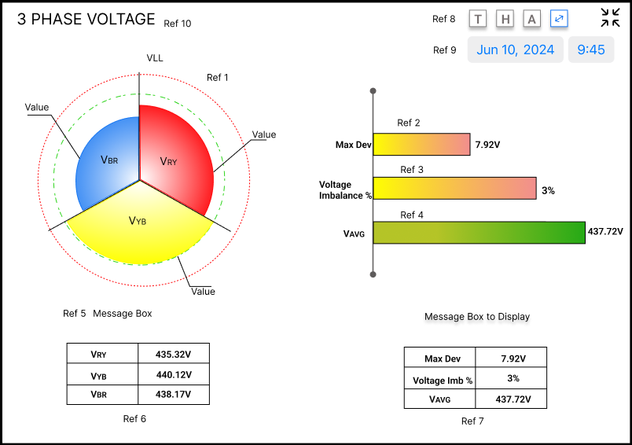

3PH LINE-TO-LINE VOLTAGE

Reference Points

1. POLAR CHART (TAGS: VRY, VYB, VBR)
   1. GET RealTime value – Client/Plant/HT/Device ID
   2. TAGS: VRY, VYB, VBR
   3. Dynamic fill – style & colour change w.r.t ranges
   4. 120deg each phase, Sequence – CW - VRY, VYB, VBR
   5. V_RY = Red; V_YB = Yellow; V_BR=Blue (Make a Standard)
   6. Dotted Circle/shaded ring w.r.t ranges (Acceptable – G; Warning – Y; Critical – R)
   7. Polar Segment Stable: L-L voltages Acceptable Range
   8. Polar Segment Ripples (polar origin to out)- every 3sec: L-L voltages Warning Range
   9. Polar Segment Enlarge & Flash - every 2sec: L-L voltages Critical Range
   10. When V_AVG non-zero [Polar chart outer max= +30% Nominal Voltage; inner min= -30% Nominal Voltage]
   11. When V_AVG = 0V - Panel Tripped [Polar chart/H Bar plot – Grey out]
   12. Standard Tool Tip
   13. Display value of Polar Segment
2. HORIZONTAL BAR PLOT (VLL_MAX_DEV)
   1. Label – Maximum Voltage Deviation (Max Voltage Dev)
   2. Max Voltage Deviation is the maximum absolute difference between any one phase’s line-to-line voltage (VRY, VYB, VBR) and the average (AVG_VLL) of all three phase voltages.
   3. Max Voltage Deviation = Max|V_phase − V_avg|
   4. Dynamic bar – Colour & Style
   5. Acceptable range – Stable
   6. Warning Range – Mild Ripples
   7. Critical – Mild Enlarge & Flash
   8. At the end of Bar – show RT value
   9. Standard Tool Tip
3. HORIZONTAL BAR PLOT (VLL_MAX_DEV_PERCENT)
   1. Label – Maximum Voltage Deviation Percentage (Max Voltage Dev %)
   2. Max Deviation % is calculated as:

(Max|V_phase − V_avg| ÷ V_avg) × 100

* 1. Dynamic bar – Colour & Style
  2. Acceptable range – Stable
  3. Warning Range – Mild Ripples
  4. Critical – Mild Enlarge & Flash
  5. At the end of Bar – show RT value
  6. Standard Tool Tip

Backend Logic

// NodeJS --- VLL Max Deviation ---

let VLL_MAX_DEV = Math.max(

Math.abs(event.VRY - event.AVG_VLL),

Math.abs(event.VYB - event.AVG_VLL),

Math.abs(event.VBR - event.AVG_VLL)

);

let VLL_MAX_DEV_PERCENT = (VLL_MAX_DEV / event.AVG_VLL) * 100;

1. HORIZONTAL BAR - 3PH AVERAGE LINE TO LINE VOLTAGE (AVG_VLL)
   1. GET RealTime value – Client/Plant/HT/Device ID
   2. Tag: AVG_VLL
   3. Label – AVG VOLTAGE
   4. Dynamic bar – Colour & Style
   5. Acceptable range – Stable
   6. Warning Range – Mild Ripples
   7. Critical – Mild Enlarge & Flash
   8. At the end of Bar – show RT value
   9. Standard Tool Tip
2. MESSAGE BOX
   1. Below Polar Chart
      1. Healthy (logic: V_AVG in AR)
      2. Warning (logic: V_AVG in WR),
      3. Critical (logic: V_AVG in CR)
      4. Feeder Trip (logic: V_AVG ~ 0 volts)
   2. Below Voltage Imbalance bar plots
      1. Healthy (logic: VLL_MAX_DEV_PERCENT in AR)
      2. Warning (logic: VLL_MAX_DEV_PERCENT in WR),
      3. Critical (logic: VLL_MAX_DEV_PERCENT in CR)
3. REALTIME DATA CARD - VOLTAGE
   1. RT VRY, VYB, VBR– Columns [Key, Value, AR/WR/CR Range Icon]

|  |  |  |
| --- | --- | --- |
| **KEY** | **VALUE** | **RANGE ICON** |
| VRY | 11.2 kV |  |
| VYB | 10.95 kV |  |
| VBR | * 1. V |  |

1. REALTIME DATA CARD – IMBALANCE
   1. RT – VLL_MAX_DEV, VLL_MAX_DEV_PERCENT, V_AVG – Key, Value, AR/WR/CR Range Icon

|  |  |  |
| --- | --- | --- |
| **KEY** | **VALUE** | **RANGE ICON** |
| VLL_MAX_DEV | 158 V |  |
| VLL_MAX_DEV_PERCENT | 1.2 % |  |
| V_AVG | * 1. V |  |

1. TOP RIGHT CORNER – CLICK ICON BUTTONS TO NAVIGATE
   1. Historical Plot
   2. Time Series Table
   3. Alert Log Page
   4. IEC/IS Standards
   5. System Config Panel
   6. Screen Enlarge
2. REAL TIME DATE & TIME
3. LABEL - 3PH HT LINE - LINE VOLTAGE
4. TOOL TIP WHILE HOVER



Format:

1. Line 1 - <Panel Name & ID>: <Message>
2. Line 2 – <TAG>: <Real Time Value> <Units>
3. Line 3 - <Time Stamp>
4. Tool Tip cursor with x & y axis dotted lines
5. Message
   1. Healthy (logic: V_AVG in AR)
   2. Warning (logic: V_AVG in WR),
   3. Critical (logic: V_AVG in CR)
   4. Feeder Trip (logic: V_AVG ~ 0 volts)

## LT DISTRIBUTION PANEL



3PH LINE-TO-LINE VOLTAGE

Reference Points

1. POLAR CHART (TAGS: VRY, VYB, VBR)
   1. GET RealTime value – Client/Plant/HT/Device ID
   2. TAGS: VRY, VYB, VBR
   3. Dynamic fill – style & colour change w.r.t ranges
   4. 120deg each phase, Sequence – CW - VRY, VYB, VBR
   5. V_RY = Red; V_YB = Yellow; V_BR=Blue (Make a Standard)
   6. Dotted Circle/shaded ring w.r.t ranges (Acceptable – G; Warning – Y; Critical – R)
   7. Polar Segment Stable: L-L voltages Acceptable Range
   8. Polar Segment Ripples (polar origin to out)- every 3sec: L-L voltages Warning Range
   9. Polar Segment Enlarge & Flash - every 2sec: L-L voltages Critical Range
   10. When V_AVG non-zero [Polar chart outer max= +30% Nominal Voltage; inner min= -30% Nominal Voltage]
   11. When V_AVG = 0V - Panel Tripped [Polar chart/H Bar plot – Grey out]
   12. Standard Tool Tip
   13. Display value of Polar Segment
2. HORIZONTAL BAR PLOT (VLL_MAX_DEV)
   1. Label – Maximum Voltage Deviation (Max Voltage Dev)
   2. Max Voltage Deviation is the maximum absolute difference between any one phase’s line-to-line voltage (VRY, VYB, VBR) and the average (AVG_VLL) of all three phase voltages.
   3. Max Voltage Deviation = Max|V_phase − V_avg|
   4. Dynamic bar – Colour & Style
   5. Acceptable range – Stable
   6. Warning Range – Mild Ripples
   7. Critical – Mild Enlarge & Flash
   8. At the end of Bar – show RT value
   9. Standard Tool Tip
3. HORIZONTAL BAR PLOT (VLL_MAX_DEV_PERCENT)
   1. Label – Maximum Voltage Deviation Percentage (Max Voltage Dev %)
   2. Max Deviation % is calculated as:

(Max|V_phase − V_avg| ÷ V_avg) × 100

* 1. Dynamic bar – Colour & Style
  2. Acceptable range – Stable
  3. Warning Range – Mild Ripples
  4. Critical – Mild Enlarge & Flash
  5. At the end of Bar – show RT value
  6. Standard Tool Tip

Backend Logic

// NodeJS --- VLL Max Deviation ---

let VLL_MAX_DEV = Math.max(

Math.abs(event.VRY - event.AVG_VLL),

Math.abs(event.VYB - event.AVG_VLL),

Math.abs(event.VBR - event.AVG_VLL)

);

let VLL_MAX_DEV_PERCENT = (VLL_MAX_DEV / event.AVG_VLL) * 100;

1. HORIZONTAL BAR - 3PH AVERAGE LINE TO LINE VOLTAGE (AVG_VLL)
   1. GET RealTime value – Client/Plant/HT/Device ID
   2. Tag: AVG_VLL
   3. Label – AVG VOLTAGE
   4. Dynamic bar – Colour & Style
   5. Acceptable range – Stable
   6. Warning Range – Mild Ripples
   7. Critical – Mild Enlarge & Flash
   8. At the end of Bar – show RT value
   9. Standard Tool Tip
2. MESSAGE BOX
   1. Below Polar Chart
      1. Healthy (logic: V_AVG in AR)
      2. Warning (logic: V_AVG in WR),
      3. Critical (logic: V_AVG in CR)
      4. Feeder Trip (logic: V_AVG ~ 0 volts)
   2. Below Voltage Imbalance bar plots
      1. Healthy (logic: VLL_MAX_DEV_PERCENT in AR)
      2. Warning (logic: VLL_MAX_DEV_PERCENT in WR),
      3. Critical (logic: VLL_MAX_DEV_PERCENT in CR)
3. REALTIME DATA CARD - VOLTAGE
   1. RT VRY, VYB, VBR– Columns [Key, Value, AR/WR/CR Range Icon]

|  |  |  |
| --- | --- | --- |
| **KEY** | **VALUE** | **RANGE ICON** |
| VRY | 420.23V |  |
| VYB | 415.56V |  |
| VBR | 418.32V |  |

1. REALTIME DATA CARD – IMBALANCE
   1. RT – VLL_MAX_DEV, VLL_MAX_DEV_PERCENT, V_AVG – Key, Value, AR/WR/CR Range Icon

|  |  |  |
| --- | --- | --- |
| **KEY** | **VALUE** | **RANGE ICON** |
| VLL_MAX_DEV | 15 V |  |
| VLL_MAX_DEV_PERCENT | 1.2 % |  |
| V_AVG | V |  |

1. TOP RIGHT CORNER – CLICK ICON BUTTONS TO NAVIGATE
   1. Historical Plot
   2. Time Series Table
   3. Alert Log Page
   4. IEC/IS Standards
   5. System Config Panel
   6. Screen Enlarge
2. REAL TIME DATE & TIME
3. LABEL - 3PH HT LINE - LINE VOLTAGE
4. TOOL TIP WHILE HOVER

Format:

1. Line 1 - <Panel Name & ID>: <Message>
2. Line 2 – <TAG>: <Real Time Value> <Units>
3. Line 3 - <Time Stamp>
4. Message
   1. Healthy (logic: V_AVG in AR)
   2. Warning (logic: V_AVG in WR),
   3. Critical (logic: V_AVG in CR)
   4. Feeder Trip (logic: V_AVG ~ 0 volts)

## INDIVIDUAL MACHINE



3PH LINE-TO-LINE VOLTAGE

Reference Points

1. POLAR CHART (TAGS: VRY, VYB, VBR)
   1. GET RealTime value – Client/Plant/HT/Device ID
   2. TAGS: VRY, VYB, VBR
   3. Dynamic fill – style & colour change w.r.t ranges
   4. 120deg each phase, Sequence – CW - VRY, VYB, VBR
   5. V_RY = Red; V_YB = Yellow; V_BR=Blue (Make a Standard)
   6. Dotted Circle/shaded ring w.r.t ranges (Acceptable – G; Warning – Y; Critical – R)
   7. Polar Segment Stable: L-L voltages Acceptable Range
   8. Polar Segment Ripples (polar origin to out)- every 3sec: L-L voltages Warning Range
   9. Polar Segment Enlarge & Flash - every 2sec: L-L voltages Critical Range
   10. When V_AVG non-zero [Polar chart outer max= +30% Nominal Voltage; inner min= -30% Nominal Voltage]
   11. When V_AVG = 0V - Panel Tripped [Polar chart/H Bar plot – Grey out]
   12. Standard Tool Tip
   13. Display value of Polar Segment
2. HORIZONTAL BAR PLOT (VLL_MAX_DEV)
   1. Label – Maximum Voltage Deviation (Max Voltage Dev)
   2. Max Voltage Deviation is the maximum absolute difference between any one phase’s line-to-line voltage (VRY, VYB, VBR) and the average (AVG_VLL) of all three phase voltages.
   3. Max Voltage Deviation = Max|V_phase − V_avg|
   4. Dynamic bar – Colour & Style
   5. Acceptable range – Stable
   6. Warning Range – Mild Ripples
   7. Critical – Mild Enlarge & Flash
   8. At the end of Bar – show RT value
   9. Standard Tool Tip
3. HORIZONTAL BAR PLOT (VLL_MAX_DEV_PERCENT)
   1. Label – Maximum Voltage Deviation Percentage (Max Voltage Dev %)
   2. Max Deviation % is calculated as:

(Max|V_phase − V_avg| ÷ V_avg) × 100

* 1. Dynamic bar – Colour & Style
  2. Acceptable range – Stable
  3. Warning Range – Mild Ripples
  4. Critical – Mild Enlarge & Flash
  5. At the end of Bar – show RT value
  6. Standard Tool Tip

Backend Logic

// NodeJS --- VLL Max Deviation ---

let VLL_MAX_DEV = Math.max(

Math.abs(event.VRY - event.AVG_VLL),

Math.abs(event.VYB - event.AVG_VLL),

Math.abs(event.VBR - event.AVG_VLL)

);

let VLL_MAX_DEV_PERCENT = (VLL_MAX_DEV / event.AVG_VLL) * 100;

1. HORIZONTAL BAR - 3PH AVERAGE LINE TO LINE VOLTAGE (AVG_VLL)
   1. GET RealTime value – Client/Plant/HT/Device ID
   2. Tag: AVG_VLL
   3. Label – AVG VOLTAGE
   4. Dynamic bar – Colour & Style
   5. Acceptable range – Stable
   6. Warning Range – Mild Ripples
   7. Critical – Mild Enlarge & Flash
   8. At the end of Bar – show RT value
   9. Standard Tool Tip
2. MESSAGE BOX
   1. Below Polar Chart
      1. Healthy (logic: V_AVG in AR)
      2. Warning (logic: V_AVG in WR),
      3. Critical (logic: V_AVG in CR)
      4. Feeder Trip (logic: V_AVG ~ 0 volts)
   2. Below Voltage Imbalance bar plots
      1. Healthy (logic: VLL_MAX_DEV_PERCENT in AR)
      2. Warning (logic: VLL_MAX_DEV_PERCENT in WR),
      3. Critical (logic: VLL_MAX_DEV_PERCENT in CR)
3. REALTIME DATA CARD - VOLTAGE
   1. RT VRY, VYB, VBR– Columns [Key, Value, AR/WR/CR Range Icon]

|  |  |  |
| --- | --- | --- |
| **KEY** | **VALUE** | **RANGE ICON** |
| VRY | 420.23V |  |
| VYB | 415.56V |  |
| VBR | 418.32V |  |

1. REALTIME DATA CARD – IMBALANCE
   1. RT – VLL_MAX_DEV, VLL_MAX_DEV_PERCENT, V_AVG – Key, Value, AR/WR/CR Range Icon

|  |  |  |
| --- | --- | --- |
| **KEY** | **VALUE** | **RANGE ICON** |
| VLL_MAX_DEV | 15 V |  |
| VLL_MAX_DEV_PERCENT | 1.2 % |  |
| V_AVG | V |  |

1. TOP RIGHT CORNER – CLICK ICON BUTTONS TO NAVIGATE
   1. Historical Plot
   2. Time Series Table
   3. Alert Log Page
   4. IEC/IS Standards
   5. System Config Panel
   6. Screen Enlarge
2. REAL TIME DATE & TIME
3. LABEL - 3PH HT LINE - LINE VOLTAGE
4. TOOL TIP WHILE HOVER

Format:

1. Line 1 - <Panel Name & ID>: <Message>
2. Line 2 – <TAG>: <Real Time Value> <Units>
3. Line 3 - <Time Stamp>
4. Message
   1. Healthy (logic: V_AVG in AR)
   2. Warning (logic: V_AVG in WR),
   3. Critical (logic: V_AVG in CR)
   4. Feeder Trip (logic: V_AVG ~ 0 volts)

# WIDGET 2.1 – 3PH LINE - LINE VOLTAGE HISTORICAL CHART

## HT DISTRIBUTION PANEL

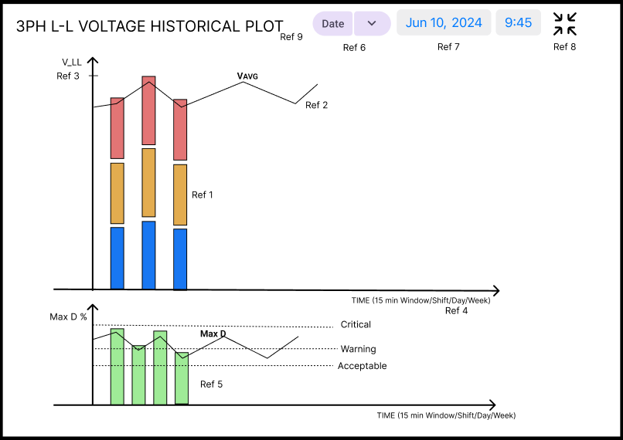

Reference Points

1. STACKED BAR PLOT
   1. VRY(Top-RED), VYB(Middle-YELLOW), VBR(Bottom-BLUE)
   2. Apply average to build bars
   3. Zoom in/out function with auto scaled axis
   4. Dynamic Bar length based on Value
   5. Dynamic bar – Gradient Colour & Style
      1. Acceptable range – Stable Bar
      2. Warning Range – Mild Ripples on Bar
      3. Critical – Mild Enlarge & Flash Bar
      4. Tool Tip hover function
2. CONTINOUS SMOOTH LINE
   1. Average Line to Line 3PH Voltage - AVG_LL
   2. Continuous Smooth Line Over & Sync with Stacked Bar Plot
   3. Tool Tip hover function
3. Y-AXIS
   1. Complete y-axis = Average Voltage critical threshold range – Auto Scale
   2. For Power Failure interval (AVG_VLL=0) – Display on ToolTip
4. X-AXIS
   1. Auto scaled Time Window based on Date Range selection package
5. VOLTAGE IMBALANCE
   1. Bar plot – Voltage Imbalance % data
   2. Continuous line over bar plot - Voltage Imbalance data
   3. Background colour bands for acceptable, warning & critical ranges
   4. X & Y axis – Auto scaled critical threshold range & Time window
6. DATE & TIME RANGE SELECTION PACKAGE
   1. Retrieve data with custom Shift (ALL/A/B/C), Date & Time
   2. Retrieve data for Current day so far
   3. Retrieve data for Current shift so far
   4. Retrieve data for Current month so far
   5. Retrieve data for Current quarter so far
   6. Retrieve all data so far
7. DISPLAY THE SELECTED OPTION
8. ICONS
   1. Minimize window
   2. Download plot as PNG
9. LABEL
   1. HT 3PH L-L VOLTAGE HISTORICAL CHART

## LT DISTRIBUTION PANEL



Reference Points

1. STACKED BAR PLOT
   1. VRY(Top-RED), VYB(Middle-YELLOW), VBR(Bottom-BLUE)
   2. Apply average to build bars
   3. Zoom in/out function with auto scaled axis
   4. Dynamic Bar length based on Value
   5. Dynamic bar – Gradient Colour & Style
      1. Acceptable range – Stable Bar
      2. Warning Range – Mild Ripples on Bar
      3. Critical – Mild Enlarge & Flash Bar
      4. Tool Tip hover function
2. CONTINOUS SMOOTH LINE
   1. Average Line to Line 3PH Voltage - AVG_LL
   2. Continuous Smooth Line Over & Sync with Stacked Bar Plot
   3. Tool Tip hover function
3. Y-AXIS
   1. Complete y-axis = Average Voltage critical threshold range – Auto Scale
   2. For Power Failure interval (AVG_VLL=0) – Display on ToolTip
4. X-AXIS
   1. Auto scaled Time Window based on Date Range selection package
5. VOLTAGE IMBALANCE
   1. Bar plot – Voltage Imbalance % data
   2. Continuous line over bar plot - Voltage Imbalance data
   3. Background colour bands for acceptable, warning & critical ranges
   4. X & Y axis – Auto scaled critical threshold range & Time window
6. DATE & TIME RANGE SELECTION PACKAGE
   1. Retrieve data with custom Shift (ALL/A/B/C), Date & Time
   2. Retrieve data for Current day so far
   3. Retrieve data for Current shift so far
   4. Retrieve data for Current month so far
   5. Retrieve data for Current quarter so far
   6. Retrieve all data so far
7. DISPLAY THE SELECTED OPTION
8. ICONS
   1. Minimize window
   2. Download plot as PNG
9. LABEL
   1. LT 3PH L-L VOLTAGE HISTORICAL CHART

## INDIVIDUAL MACHINE



Reference Points

1. STACKED BAR PLOT
   1. VRY(Top-RED), VYB(Middle-YELLOW), VBR(Bottom-BLUE)
   2. Apply average to build bars
   3. Zoom in/out function with auto scaled axis
   4. Dynamic Bar length based on Value
   5. Dynamic bar – Gradient Colour & Style
      1. Acceptable range – Stable Bar
      2. Warning Range – Mild Ripples on Bar
      3. Critical – Mild Enlarge & Flash Bar
      4. Tool Tip hover function
2. CONTINOUS SMOOTH LINE
   1. Average Line to Line 3PH Voltage - AVG_LL
   2. Continuous Smooth Line Over & Sync with Stacked Bar Plot
   3. Tool Tip hover function
3. Y-AXIS
   1. Complete y-axis = Average Voltage critical threshold range – Auto Scale
   2. For Power Failure interval (AVG_VLL=0) – Display on ToolTip
4. X-AXIS
   1. Auto scaled Time Window based on Date Range selection package
5. VOLTAGE IMBALANCE
   1. Bar plot – Voltage Imbalance % data
   2. Continuous line over bar plot - Voltage Imbalance data
   3. Background colour bands for acceptable, warning & critical ranges
   4. X & Y axis – Auto scaled critical threshold range & Time window
6. DATE & TIME RANGE SELECTION PACKAGE
   1. Retrieve data with custom Shift (ALL/A/B/C), Date & Time
   2. Retrieve data for Current day so far
   3. Retrieve data for Current shift so far
   4. Retrieve data for Current month so far
   5. Retrieve data for Current quarter so far
   6. Retrieve all data so far
7. DISPLAY THE SELECTED OPTION
8. ICONS
   1. Minimize window
   2. Download plot as PNG
9. LABEL
   1. 3PH L-L VOLTAGE HISTORICAL CHART

# WIDGET 2.2 – 3PH LINE - LINE VOLTAGE TIME_SERIES TABLE

## HT DISTRIBUTION PANEL

1. Timeseries Data Table
2. COLUMNS
   1. Time Stamp
   2. All DB available Key/Tag
   3. Real Time value
   4. Current value Range Status (AR, WR, CR)
   5. Std Acceptable Range/Bench mark
3. Dropdown option for Latest records to show as a table – 10, 30, 50.
4. Click Icon to Download in XLS/PDF with Date Range selection Package

## LT DISTRIBUTION PANEL

1. Timeseries Data Table
2. COLUMNS
   1. Time Stamp
   2. All DB available Key/Tag
   3. Real Time value
   4. Current value Range Status (AR, WR, CR)
   5. Std Acceptable Range/Bench mark
3. Dropdown option for Latest records to show as a table – 10, 30, 50.
4. Click Icon to Download in XLS/PDF with Date Range selection Package

## INDIVIDUAL MACHINES

1. Timeseries Data Table
2. COLUMNS
   1. Time Stamp
   2. All DB available Key/Tag
   3. Real Time value
   4. Current value Range Status (AR, WR, CR)
   5. Std Acceptable Range/Bench mark
3. Dropdown option for Latest records to show as a table – 10, 30, 50.
4. Click Icon to Download in XLS/PDF with Date Range selection Package

# WIDGET 2.3 – 3PH LINE - LINE VOLTAGE ALERT LOG PAGE

## HT DISTRIBUTION PANEL

1. Panel specific Alert log page
2. Alert Dashboard
   1. Card 1: Total Pending Critical Alerts (Unacknowledged) against 1 user
   2. Card 2: Total Pending Warning Alerts (Unacknowledged) against 1 user
   3. Card 3: Total acknowledged Critical Alerts against 1 user
   4. Card 4: Total acknowledged Warning Alerts against 1 user
3. Alert Log Table
   1. Panel Name & Location
   2. Time Stamp (TS)
   3. Tag Name
   4. Alert Value with Units
   5. Alert Message (Returned to Normal, Warning!!, Critical)
   6. Event Time Stamp
   7. Acknowledge Button
   8. If acknowledged – log Username with TS
   9. Dropdown option to display latest 10, 20, 30, 50 event rows
   10. Download option – Alert log Table with date range package

## LT DISTRIBUTION PANEL

1. Panel specific Alert log page
2. Alert Dashboard
   1. Card 1: Total Pending Critical Alerts (Unacknowledged) against 1 user
   2. Card 2: Total Pending Warning Alerts (Unacknowledged) against 1 user
   3. Card 3: Total acknowledged Critical Alerts against 1 user
   4. Card 4: Total acknowledged Warning Alerts against 1 user
3. Alert Log Table
   1. Panel Name & Location
   2. Time Stamp (TS)
   3. Tag Name
   4. Alert Value with Units
   5. Alert Message (Returned to Normal, Warning!!, Critical)
   6. Event Time Stamp
   7. Acknowledge Button
   8. If acknowledged – log Username with TS
   9. Dropdown option to display latest 10, 20, 30, 50 event rows
   10. Download option – Alert log Table with date range package

## INDIVIDUAL MACHINES

1. Panel specific Alert log page
2. Alert Dashboard
   1. Card 1: Total Pending Critical Alerts (Unacknowledged) against 1 user
   2. Card 2: Total Pending Warning Alerts (Unacknowledged) against 1 user
   3. Card 3: Total acknowledged Critical Alerts against 1 user
   4. Card 4: Total acknowledged Warning Alerts against 1 user
3. Alert Log Table
   1. Panel Name & Location
   2. Time Stamp (TS)
   3. Tag Name
   4. Alert Value with Units
   5. Alert Message (Returned to Normal, Warning!!, Critical)
   6. Event Time Stamp
   7. Acknowledge Button
   8. If acknowledged – log Username with TS
   9. Dropdown option to display latest 10, 20, 30, 50 event rows
   10. Download option – Alert log Table with date range package

# WIDGET 15 -